Jamie Javis

01/20/2024

CS - 330

Module Two Milestone

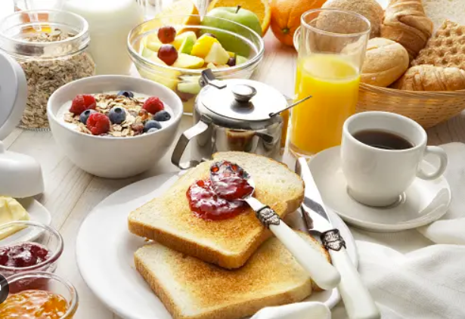

One of the objects in this scene I would like to recreate is the mug on the right. This would be a good choice because it could be made of at least two primitive shapes. For the base, I could see myself using a cylinder for the cup part. For the handle, a torus could work given that it is a donut-like shape.

For other objects, shapes such as a sphere would work for the berries. Planes could be used for the blade of the knife. A plane could also be used for the table in the background. Cubes could be used for the slices of butter or the toast. Even the top of the metal container could be a pyramid/cone shape.